Magnetic Field Localization

Spis treści

About project 1

Test Scenario 1

Permeability of human tissues 2

Parameters 2

Results 3

# About project

This program is a part of a Master’s Thesis concerning Magnetic Field Localization in the Human body.

# Test scenario

To test the possibility of using a magnetic field to locate sensors, a special scenario was created. Visualization is in Fig. 1.

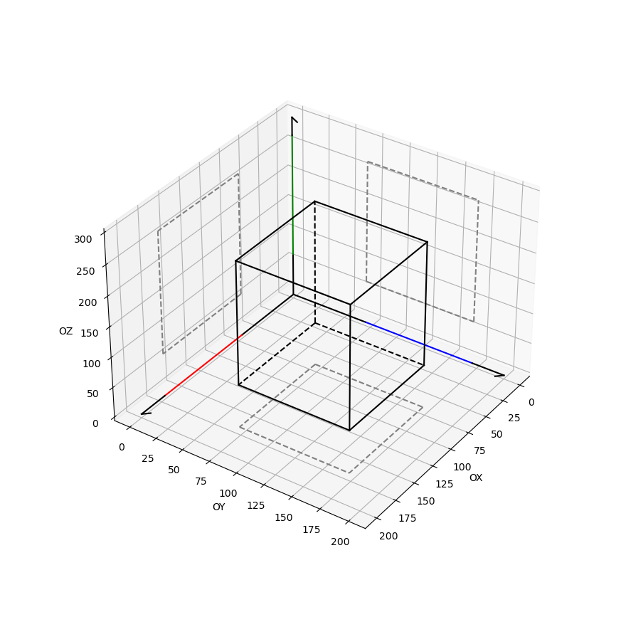

Fig. 1 Setup visualization

Let’s assume a 3d Cartesian coordinate system. In the model, three rectilinear cords generate a magnetic field: green on the Z axis, blue on the Y axis, and red on the X axis. Sensors are evenly spaced in a cuboidal space simulating the human body.

Each sensor measures the magnetic flux for each magnet (with added noise).

In the test scenario, all measurements are calculated simultaneously. However, it is assumed that magnets are powered sequentially.

# Permeability of human tissues

**Note:** This chapter is based on:

Collins, Christopher & Yang, Bei & Yang, Qing & Smith, Michael. (2002). Numerical calculations of the static magnetic field in three-dimensional multi-tissue models of the human head. Magnetic resonance imaging. 20. 413-24. 10.1016/S0730-725X(02)00507-6.

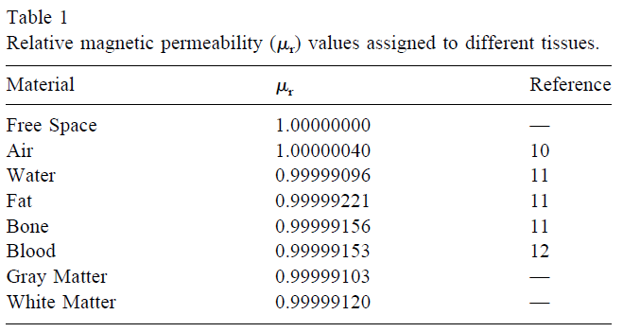

# Parameters

In this section, there are parameters used in the test simulation.

1. Current [I] = 135 kA
2. Magnetic flux [M] = 27 T (1 mm from magnet)
3. Magnetometer sensitivity = 0,22 V/T

**Note:** For this version, sensor parameters are based on:

M. Banjevic, B. Furrer and R. S. Popovic, "2D CMOS integrated magnetometer based on the miniaturized circular vertical Hall device," TRANSDUCERS 2009 - 2009 International Solid-State Sensors, Actuators and Microsystems Conference, 2009, pp. 877-880, DOI: 10.1109/SENSOR.2009.5285857.

In the future, there is a plan to use more accurate sensors for simulations.

**Note:** For safety, magnetic flux density was based on MRI parameters:

John F. Schenck, "Physical interactions of static magnetic fields with living tissues", Progress in Biophysics and Molecular Biology, Volume 87, Issues 2–3, 2005, Pages 185-204, ISSN 0079-6107, https://doi.org/10.1016/j.pbiomolbio.2004.08.009.

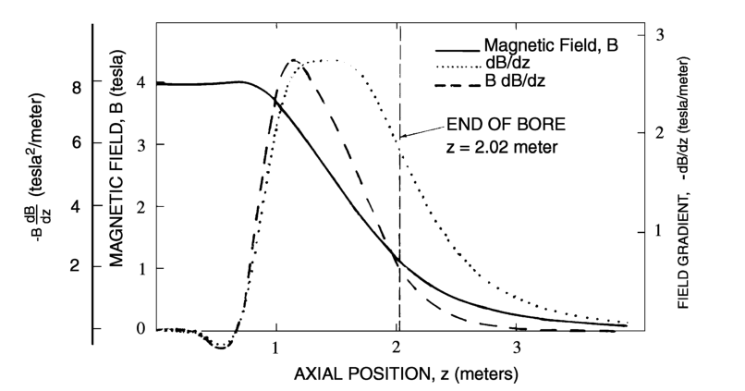

Fig. 2 "Field, gradient and force product along the axis of a large 4 T, whole-body superconducting magnet. The center of the magnet is at z = 0 and the bore ends at z = 1.02 m. The maximum gradient is 2.78 T/m at z = 1.47 m. The maximum value of B(dB/dz) is 8.79 T^2/m at z = 1.14 m (Reprinted, with permission, from Schenck et al., 1992)."

# Magnetic field characteristic

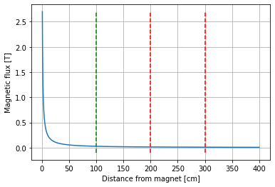

Fig. 3 Characteristic of the static magnetic field used in simulations as a function of distance from magnets. Dashed lines show a work field. Green – beginning and red – end. The left-hand red line corresponds to OX and OY, and the right-hand red line to OZ.

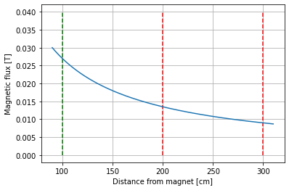

Fig. 4 placeholder

# Results

For each sensor, ten measurements were carried out and the mean position errors were calculated. For 2000 points there are 20000 calculations. Some calculations cannot be made due to a size of an error. In this simulation, 5320 calculations could not be made. However, there is at least one calculation for each point, therefore all points are depicted in Fig. 5.

The directional error is a difference between the calculated and measured flux for each magnet. A total position error is a length of a vector composed of directional errors.

Sensor positions are depicted below. Their colours reflect total position errors. The brighter the colour is, the bigger the error. The maximal calculated error equals 21,56 cm. However, the mean calculated error for all sensors equals only 6,62 cm.

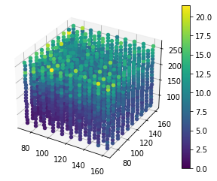

Fig. 5 Sensor positions with calculated position error. Axes are cm.

## Cross-sections

Fig. 5. is good for position and overall error distribution visualization. To illustrate the accurate error distributions, cross-sections are presented.

